**NOAA Ship THOMAS JEFFERSON Procedure Document**

Procedure:

**How and where to enter your patch values**

Creation Date:

8/30/2020

Revision Date:

03/22/2022

Software used:

SIS, Caris HIPS&SIPS, POSview, Charlene

Procedure Number:

**TBD**

Approved:

**TBD**

# Overview and Scope

A guide on how to enter and where to enter your patch test values.

# Procedure Inputs and Outputs

## Inputs:

## Outputs:

# Procedure

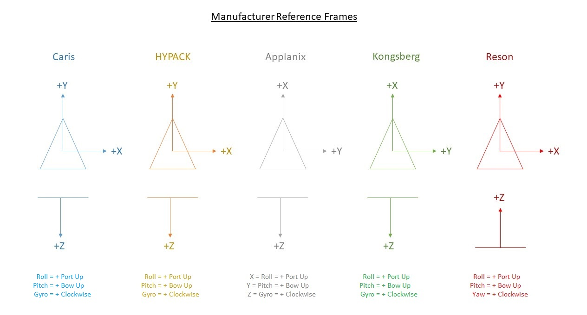

Your patch test, GAMS and Primary lever arm calibrations must be complete. Be aware of Manufacturer-set Reference Frames. These Reference Frames cannot be changed by you.

**Launch:**

Launch Patch test values on TJ are entered into POSView in “Settings” > “Installation” > “Lever Arms & Mounting Angles” within the IMU Frame w.r.t Ref. Frame section (See image below).

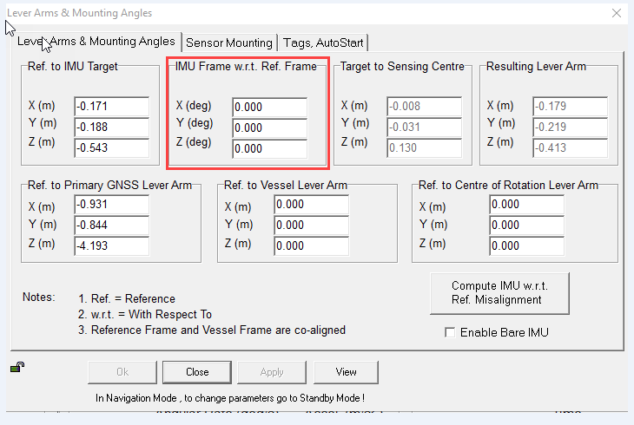

When you conduct your patch test in Caris you are rotating the TX to align with the IMU. When applying patch test values in POSView you need to reverse the signs of the values from Caris in order to then align the IMU with the TX of the sonar.

Open up the spreadsheet for the vessel that you are applying patch test values for. The values from the test should look something similar to the image below.

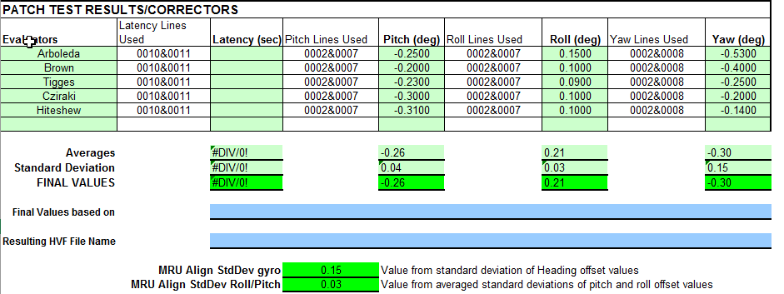

Using the image at the top of this SOP for manufacturer reference frames, we know that for Applanix that X = Roll, Y = Pitch, and Z = Gyro (Yaw). Using the image of our patch test values above, we know that the values we need to apply in POSView are X = - 0.21, Y = 0.26, and Z = 0.30 (remember to reverse the signs!). This will align the IMU with the TX in this example.

With your values now entered into POS, Click the monitor button in order to disconnect from the system and save the values. If you do not save, your values will revert when the system is restarted.

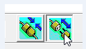

We now need to conduct another Primary Lever Arm Calibration because in applying the patch test values in POS you are changing the starting orientation of the primary antenna lever arm. Reference SOP "K:\Standard_Operating_Procedures\05_HSRR\2022 - Primary Antenna Lever Arm Calibration.docx" to conduct a Primary Lever Arm Calibration.

**Ship:**

Ship Patch test values on TJ are entered into SIS in “View” > “Tear off” > “Installation parameters” > “Sensor Setup” > “Angular Offsets” within the “Attitude 1” cells (See image below).

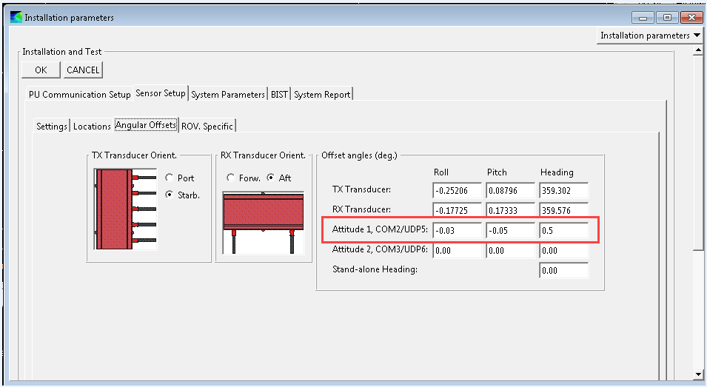

The patch test values from Caris are directly entered into their respective cells under “Attitude 1” in SIS. This is because you are aligning the TX with the IMU as you were when you conducted the patch in Caris. There is no need to conduct another Primary Lever Arm Calibration because you are not changing the IMU orientation.

# References

"K:\Standard_Operating_Procedures\05_HSRR\2022 - Primary Antenna Lever Arm Calibration.docx"